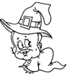 | 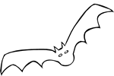
Baby Witch | Scary Bat
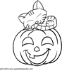 | 
Cat on Pumpkin coloring pic | Cowboy Mask
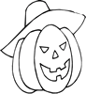 | 
Cowboy Pumpkin | Elvis Ghost
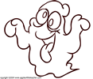 | 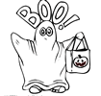
Spooky Ghost color pic | Boy in Ghost Costume coloring pic
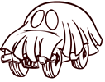 | 
Car in Ghost Costume color pic | Happy Halloween Ghost
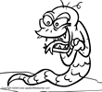 | 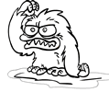
Goblin 1 color pic | Goblin 2 coloring pic
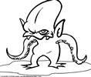 | 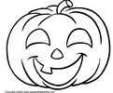
Goblin 3 coloring pic | Pumpkin color pic
 | 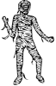
Laughing Pumpkin | Mummy
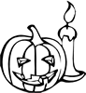 | 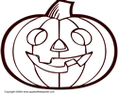
Jack-o-lantern with Candle | Jack-o-Lantern color pic
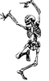 | 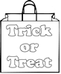
Skeleton Dancing | Trick or Treat Bag
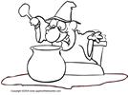 | 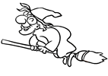
Witch's Brew color pic | Witch on Broom coloring pic
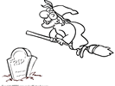
Witch on Broom 2 coloring pic

